**TRAFFIC MANAGEMENT**

**INTRODUCTION:**

Traffic management is a critical aspect of urban planning, ensuring the smooth flow of vehicles and pedestrians, reducing congestion, and enhancing overall road safety. As cities continue to grow and face increasing challenges related to traffic congestion and pollution, innovative ideas are essential to address these issues effectively. One such innovation idea involves the integration of advanced technologies and data-driven solutions to revolutionize traditional traffic management methods.

**PROBLEM STATEMENT:**

Traffic congestion problems consist of incremental delay, vehicle operating costs such as fuel consumption, pollution emissions and stress that result from interference among vehicles in the traffic stream, particularly as traffic volumes approach a road’s capacity.

**OBJECTIVES:**

**1. Safety:** Minimize accidents and ensure road safety.

**2.Efficiency:** Optimize traffic flow and reduce congestion.

**3.Sustainability:** Reduce environmental impact and promote sustainable transportation.

**4.Accessibility:** Improve access for all road users.

**5.Technology:** Implement advanced systems for traffic control.

**6.Compliance:** Enforce traffic rules and regulations.

**7.Infrastructure:** Plan for future growth and development.

**8.Public Awareness:** Educate the public about responsible road use.

**METHODOLOGY:**

Traffic management involves various strategies and methodologies to efficiently control and regulate traffic flow. Here's a general methodology:

* **Traffic Analysis:**

Collect data on traffic volume, patterns, and peak hours. Identify congestion hotspots and areas with safety concerns.

* **Traffic Planning:**

Develop short and long-term traffic management plans. Consider road expansions, new infrastructure, and alternative routes.

* **Traffic Signals and Signs:**

Install and maintain traffic lights, signs, and road markings. Ensure proper visibility and functionality.

* **Public Transportation:**

Promote and improve public transportation options. Encourage the use of buses, trains, and trams to reduce private vehicle traffic.

* **Traffic Enforcement:**

Enforce traffic laws through police and automated camera systems. Issue fines for violations to deter reckless driving.

* **Technology Integration:**

Implement Intelligent Transportation Systems (ITS) for real-time traffic monitoring. Use sensors, cameras, and data analysis for traffic control.

* **Road Maintenance:**

Regularly maintain and repair road infrastructure. Address potholes, damaged signs, and road hazards promptly.

* **Parking Management:**

Control parking through designated areas and pricing strategies. Promote off-street parking options.

* **Alternative Transportation:**

Encourage walking and cycling through bike lanes and pedestrian-friendly infrastructure. Promote carpooling and ridesharing.

**DATA COLLECTION AND PREPROCESSING:**

Data collection and preprocessing for traffic management using IoT (Internet of Things) involves gathering data from various sensors and devices, then processing and preparing it for analysis. Here's a methodology for this process:

**1. Sensor Deployment:**

Install IoT sensors and devices at strategic locations, including traffic signals, intersections, roadways, and parking areas. Use sensors like cameras, lidar, radar, inductive loops, and environmental sensors to capture relevant data.

**2. Data Gathering:**

Sensors continuously collect data on traffic volume, vehicle speed, congestion, environmental conditions (e.g., temperature, humidity), and other relevant parameters. Data can be transmitted wirelessly to a central data hub.

**3. Data Communication:**

Employ IoT communication protocols such as MQTT, HTTP, or CoAP to transmit data from sensors to a central server or cloud platform. Ensure data transmission is secure and reliable.

**4. Data Storage:**

Store the collected data in a centralized database or cloud storage for easy access and retrieval. Consider using a time-series database for time-sensitive data like traffic flow.

**5. Data Preprocessing:**

Clean and preprocess raw data to handle missing values, outliers, and data inconsistencies. Aggregate data into appropriate time intervals (e.g., minutes or hours) for analysis.

**6. Data Transformation:**

Convert data formats if necessary and align timestamps to create a uniform dataset. Normalize data to a common scale for meaningful analysis.

**7. Real-time Processing:**

Process a subset of data in real-time for immediate traffic management decisions, such as adaptive signal control.

**8. Data Analytics and Visualization**:

Use data analytics tools and techniques to gain insights into traffic patterns, congestion, and environmental conditions. Create dashboards and visualization tools for real-time monitoring and historical analysis.

**RESULTS AND FINDING:**

Traffic management using IoT provides real-time results and findings, including insights into congestion patterns, traffic flow optimization, and accident prevention. By analyzing data from IoT sensors, it's possible to identify high-traffic areas, reduce congestion through adaptive signal control, and enhance safety measures. IoT enables predictive analytics for proactive management, informs public of real-time traffic updates, and optimizes public transportation systems. Additionally, environmental impacts, cost savings, and public awareness campaigns are positively influenced by IoT-based traffic management, leading to safer and more sustainable urban mobility.

**BLOCK DIAGRAM:**

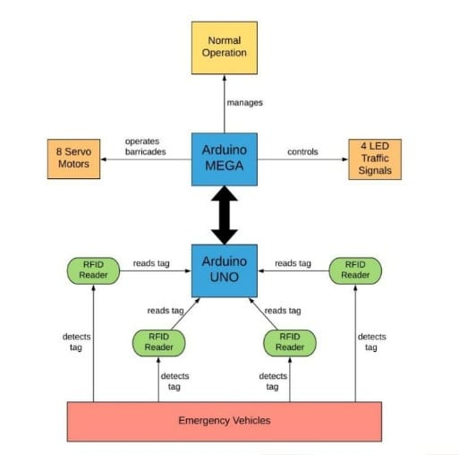

**PROGRAM:**

void setup () {

// configure the output pins

pinMode (2, OUTPUT);

pinMode (3, OUTPUT);

pinMode (4, OUTPUT);

pinMode (5, OUTPUT);

pinMode (6, OUTPUT);

pinMode (7, OUTPUT);

pinMode (8, OUTPUT);

pinMode (9, OUTPUT);

pinMode (10, OUTPUT);

}

void loop ()

{

digitalWrite (2,1); //enables the 1st set of signals

digitalWrite (7,1);

digitalWrite (10,1);

digitalWrite (4,0);

digitalWrite (3,0);

digitalWrite (6,0);

digitalWrite (8,0);

digitalWrite (9,0);

digitalWrite (5,0);

delay (10000);

digitalWrite (3,1); //enables the yellow lights

digitalWrite (6,1);

digitalWrite (2,0);

digitalWrite (7,0);

delay (2000);

}

**CONCLUSION:**

IoT-based traffic management systems have revolutionized urban transportation. They offer real-time data and smart decision-making, optimizing traffic flow, reducing congestion, and improving road safety. These systems enhance sustainability and quality of life, but privacy and security must be carefully considered. Collaborative efforts among stakeholders will be essential for realizing the full potential of IoT in traffic management, creating smarter and more efficient cities.